Dear parents,

During January 16-27th, we are celebrating literacy at École John Stubbs by holding our second Read-A-Thon, in collaboration with PAC and Greater Victoria Public Library as well as support from School House Teaching. Funds raised during this school-wide event will be used to help build our French collection, while encouraging a lifelong love of reading at home and at school. Students will be asked to follow their home-reading program currently used in their classrooms. If they have been reading for 15 minutes each night, they will continue to read for 15 minutes. However, this time each student is asked to record what they are reading and how long they read. Students are encouraged to ask their parents, relatives, and friends of the family to sponsor them either for every minute the child reads (ex. $.05 / minute) or as a lump sum ($20 total regardless of how much the child read). Teachers will be sending home a Tracking Sheet and a Sponsor Sheet before this event.

Students can choose to read individually, be read to, or read to someone. Prizes and incentives will be given throughout this event. After the Read-A-Thon, please send all sponsorship money to École John Stubbs by February 3rd. Please make cheques to JS PAC.

*We will also be holding a used book exchange January 23-25th. We are asking students to bring gently used books to school before and during the first week of the Read-a-thon, in either French or English. On the second week we will hold the book exchange and each student will then have a chance to choose a gently used book to bring home.

*Your child will also be bringing home a Bingo card that will be used in collaboration with GVPL. Once completed, students may enter it in a draw for a chance to win a prize.

*If you would like a public library card, please fill out this form: http://www.gvpl.ca/assets/PDF/Audiences/Parents--Educators/outreach-library-card-application-form.pdf

Please support our Read-a-Thon so that your child will have more French books to read, share, and enjoy!
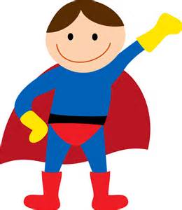

Stephanie Cave
Teacher-Librarian
École John Stubbs

***Events such as these require parent volunteers. Parents are being asked to help with the book exchange and tracking sheets. Please sign up at the following link: https://www.volunteersignup.org/FECWF
Week 2 :
Jan 23-25th : Used book exchange
Jan 24th : Read non-fiction day
Jan 25th : Read in French only day
Jan 26th : Poem in your pocket day. Bring or write a poem and put it in your pocket. Read it when asked.
Jan 27th : Milk, cookies, and pyjama day. Please bring 2 cookies to school. Milk will be provided by PAC.

Important dates to remember :
Week 1 :
Jan 9-20th : Send gently used books to school
Jan. 18th : GVPL Middle School Book Smack
Jan 19th : Bring your favourite book to share
Jan 20th : Dress as your favourite book character

