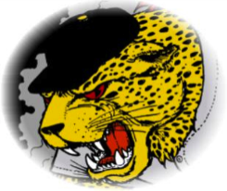
Ecole John Stubbs Spirit Wear
Orders due Thursday, March 16
Please make all cheques to School District 62.
No late orders will be accepted as the order will go in the next day.
Sample Sizes available in the office.

Student name: Teacher:
Parent name:
Phone number:

Youth T-Shirts
 | S | M | L | XL | Price w/tax | Total
Black |  |  |  |  | $16.00 | $
Grey |  |  |  |  | $16.00 | $
Navy |  |  |  |  | $16.00 | $

Adult T-Shirts
 | S | M | L | XL | Price w/tax | Total
Black |  |  |  |  | $20.00 | $
Grey |  |  |  |  | $20.00 | $
Navy |  |  |  |  | $20.00 | $

Youth Zip Up Hoodies
 | S | M | L | XL | Price w/tax | Total
Black |  |  |  |  | $35.00 | $
Grey |  |  |  |  | $35.00 | $
Navy |  |  |  |  | $35.00 | $

Adult Zip Up Hoodies
 | S | M | L | XL | Price w/tax | Total
Black |  |  |  |  | $38.00 | $
Grey |  |  |  |  | $38.00 | $
Navy |  |  |  |  | $38.00 | $

